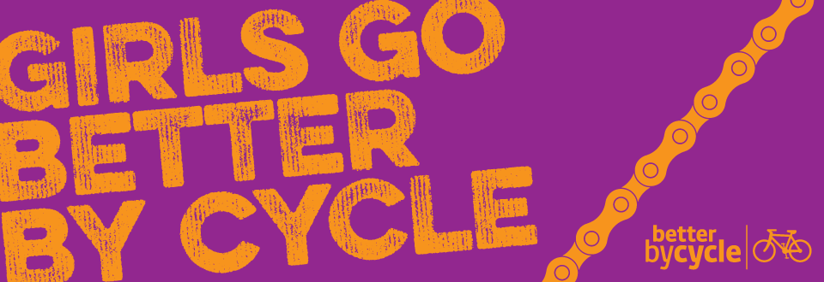

Programme of Women’s cycling events in March

Name of the event:

Organiser of the event:

Type of event/activity:
Ride |  | Discount |  | Other
Training |  | Try-out

Please tell us about the numbers at your event(s):
How long did your event run for?
How many women came to your event (if necessary, estimates are fine)
Did you collect any surveys?
If so how many
Was it a free event (Y/N)?
If you got any new member sign-ups, how many?

Feedback – what effect do you feel being involved in the programme has had on your group, organisation or business? Think about things like numbers of people, networks and social media, press and public interest, what went well and any lessons learned.

