
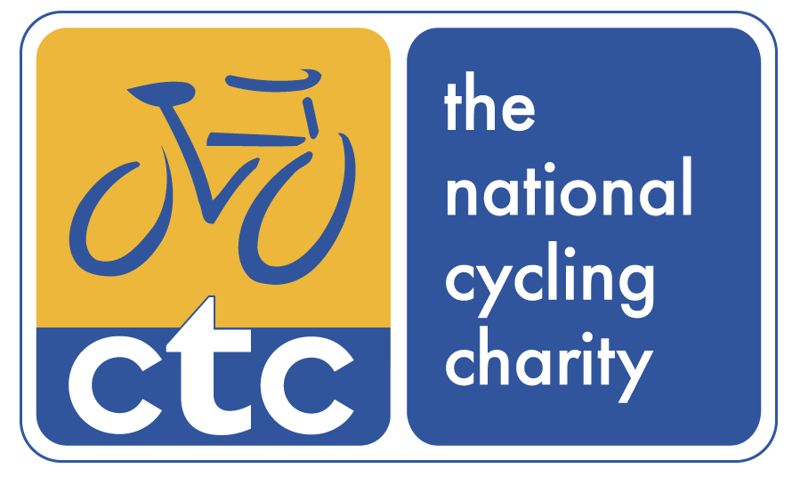

Trail

CTC Training
62-68 Thirlwell Road, Sheffield, S8 9TF

Tel: 0844 736 8463
Email: mtb@ctc.org.uk
www.ctc.org.uk/education
Course Resource
Unit 2: Riding Ability
Trail Mountain Bike Leader Award
Leader & Instructor Awards
Title | Link | Page
Introduction | Go there | 3
CTC | Go there | 3
Section 3 – Best Practice Guide | Go there | 4
Unit 2 – Riding Ability | Go there | 5
Contacting CTC | Go there | 6

Contents

© Copyright CTC 1996-2013

All rights reserved. No part of this publication may be reproduced in any form or by any means without permission from the publishers.

To ensure that maintenance of appropriate and high standards of the Awards, CTC reserves the right to alter any course specification or detail without notice.

Unit 2 – Riding Ability

Welcome to your Trail Mountain Bike Leader Resource. This resource is designed to aid your role as an excellent CTC mountain bike leader now and in the future. You should find that you need to refer to it regularly even when leading often, as its content is entirely applicable to your circumstances.

This resource is made up of several individual sections, which this is a section of part 3:

- Information on the Trail Mountain Bike Leader Award, how this fits within the National Mountain Bike Leader Award Scheme and the National Mountain Bike Skill Awards.
- CTC products and services and how these improve and enable the environment for all cyclists and mountain biking.
- Best practice information and principles for each section of the Trail Leader Award Scheme. These sections are presented in the same unit order as the qualification itself.
- Your Logbook for the recording of future personal and leading rides that you undertake, and ensuring your CPD is recorded
- Pro-formas and exemplar forms for you to use in applying CTC’s best practice in documenting your methods.

All sections are available separately as downloads from Trail Leader Resource page.

CTC
CTC, the national cycling charity administers and provides the National Mountain Bike Leader Award Scheme as a National Governing Organisation. Its purposes in doing this are to enable best practice in activity provision and accessibility to help engage millions of people in mountain biking and cycling.

At CTC:

- We protect cyclists
- We inspire people to cycle
- We promote cycling
- We operate a highly effective organisation
CTC provide a wide range of services to assist Mountain Bike Leaders both in their role as leaders and as individuals. More information about CTC is available in the CTC support and services downloadable documents and at www.ctc.org.uk.

Section 3 - Best Practice Guide

This section is made up of all the units that comprise the Trail Leader Award qualification and is a guide to implementing best practice in these core areas. Each section covers all aspects of how to plan and deliver led rides safely to a high level of competence. You should refer to this section regularly as its content is of key importance to keeping you at the appropriate standard for mountain bike leading. It can also be used as a tool to outline essential aspects of mountain bike practice and safety to the individuals you are working with.

Each unit covers a select area of importance with sub sections underlining the key points that fall under that heading. The units are ordered as follows:
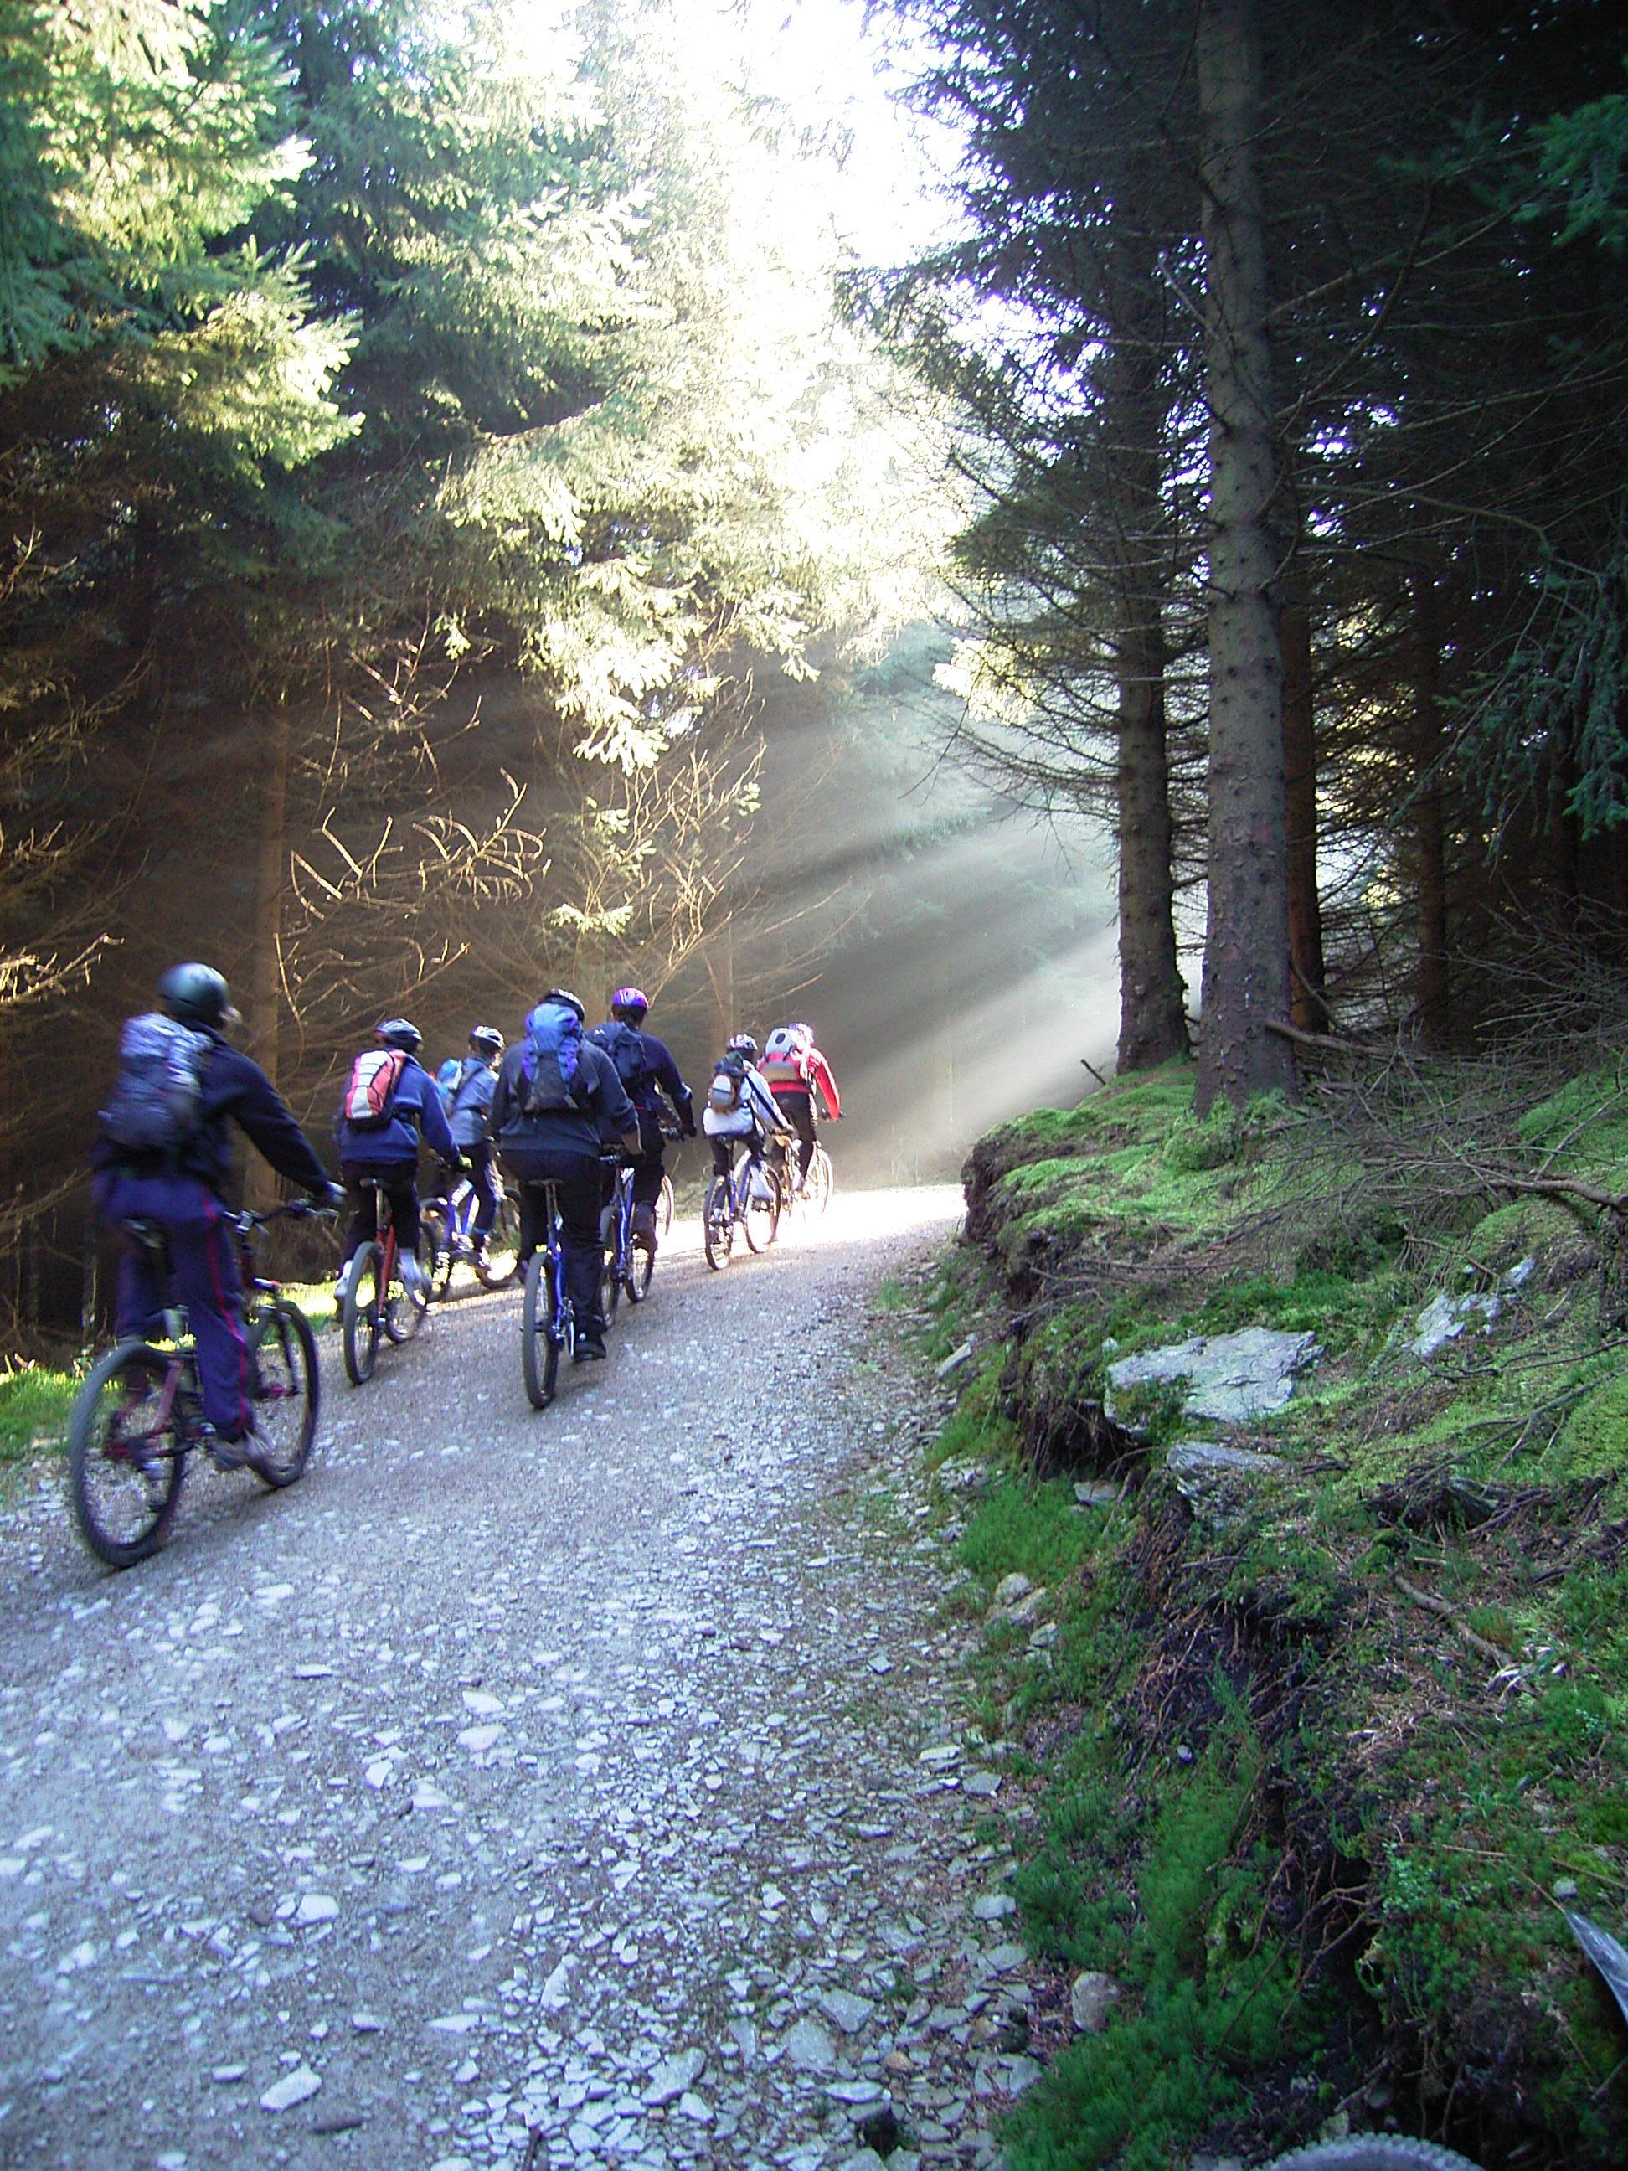
Unit Title
Unit 1: Ride preparation

Unit 2: Riding ability

Unit 3: Instruct others riding skills

Unit 4: Trailside maintenance

Unit 5: Navigation

Unit 6: Pre-ride checks

Unit 7: Leading groups

Unit 8: Dealing with emergencies

Unit 9: Environment

Unit 10: Ending the ride

Each unit can be downloaded from the Trail Leader Award Resource page.

Unit 2: Riding Ability
As a Trail Leader, you need to be a competent mountain biker in Trail terrain. To do this you will:
- Ride safely at all times.
- Be aware of other riders.
- Identify and select the correct gear effectively.
- Brake and stop effectively.
- Show appropriate body positions when sitting and standing.
- Ride noticeable and extended uphill and downhill trails.
- Identify Technical terrain and not use it when leading groups.
- Be clearly able to complete rides of 15km or more within 3 hours.

Trail Leader riding techniques
As a Trail Leader you have reached or exceeded these specific riding capacities. To reinforce these skills, each aspect has been outlined through the use of four key riding skills: gears and pedals; speed and braking; body position; anticipation.

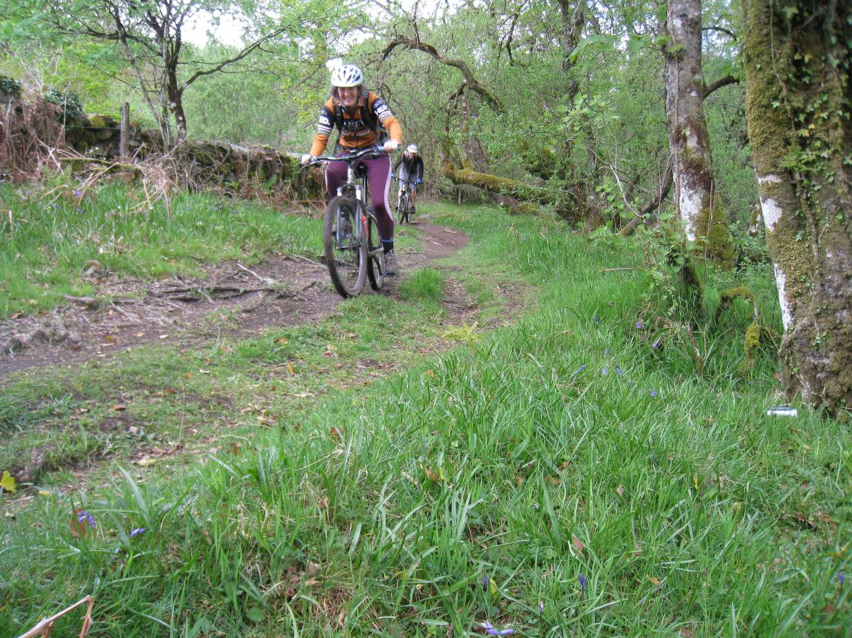

Contacting CTC
You can contact CTC’s various departments as below:

CTC National Office | CTC Education
General enquiries; Holidays; Finances; Campaigns; Commercial; National strategies; Course booking | National Mountain Bike Award Scheme; Courses; Qualifications; Technical support
CTC  Parklands  Railton Road  Guildford  GU2 9JX | CTC Education  62-68 Thirlwell Road  Sheffield  S8 9TF
Tel: 0844 736 8450  Email: cycling@ctc.org.uk  Web: www.ctc.org.uk | Tel: 0844 736 8463  Email: mtb@ctc.org.uk  Web: www.ctc.org.uk/education

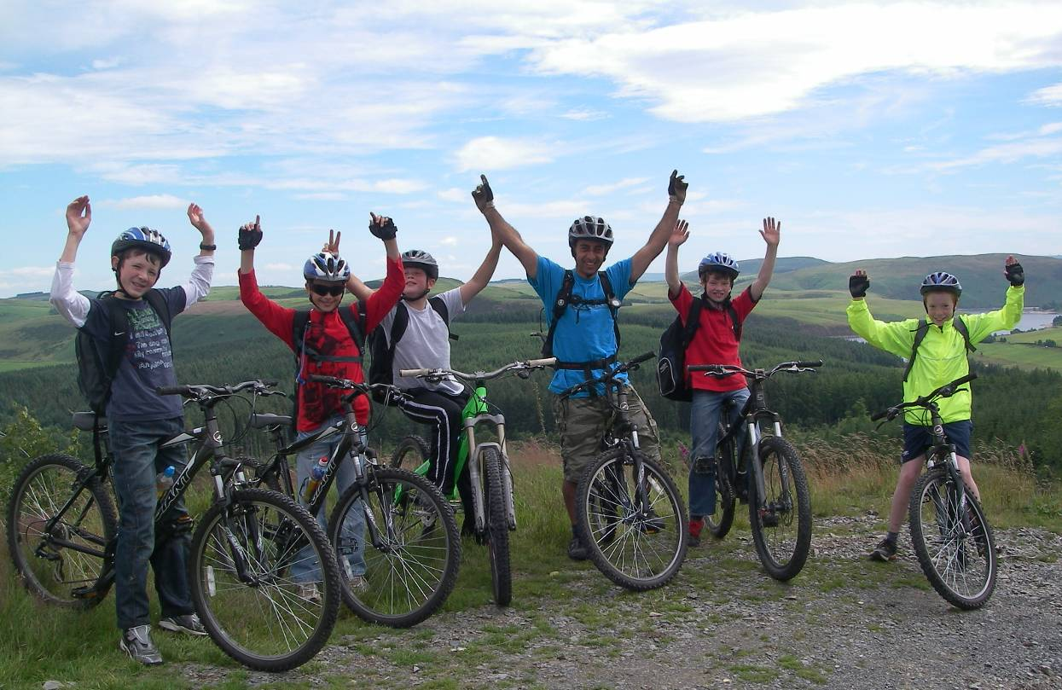

All photos and content © Copyright CTC 2012-13. E&OE.

